* In excel sheet If we want header count also then we should use getPhysicalNumberOfRows() method
* If we want record count /row count excluding header (from the first record)we can go for getLastRowNum();
* If we want column count go for getLastCellNum()

Example:

**int** cols = sheet.getRow(0).getLastCellNum();

* If we want to see the existing files stating path then use the command System.getProperty("user.dir")

Example:

XSSFWorkbook book = **new** XSSFWorkbook(System.*getProperty*("user.dir")+"\\src\\test\\java\\leaftaps\\Test_Data.xlsx");

**String Functions**

* **Split method** – splits the string based on the characters given

Example:

String name = "Apple is a fruit & Orange is a fruit";

// Split the String based on the space or symbol

String arr[] = name.split("&");

* **Trim Method** - Trims before and after space in a string

Example:

String name = "Apple is a fruit & Orange is a fruit";

//Trim the before and After whitespace in array

**for** (String arr_val : arr) {

System.***out***.println(arr_val.trim());

}

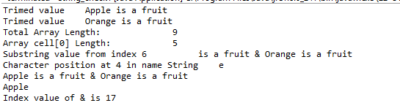

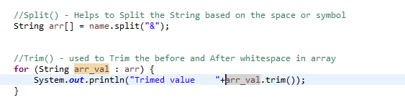 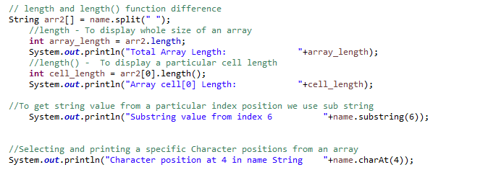 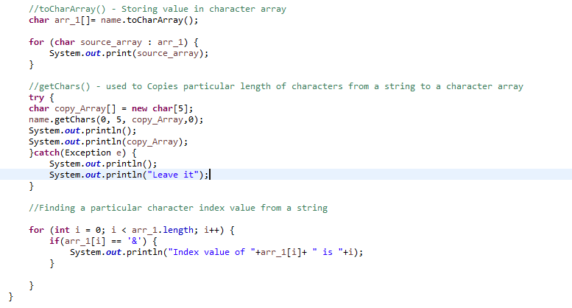

Output



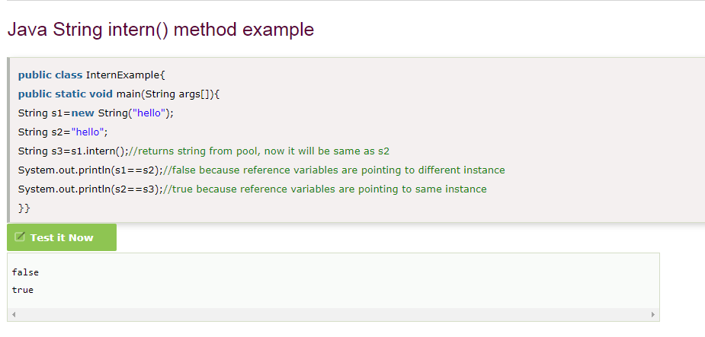

**Array Method – deepToString()**

deepToString () method helps to takes all the row and column data from an array

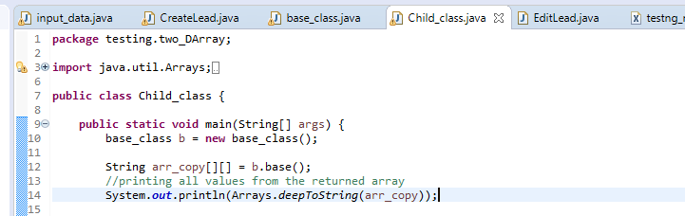

**Output**

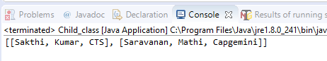

* Point method helps to store the x and y coordinate values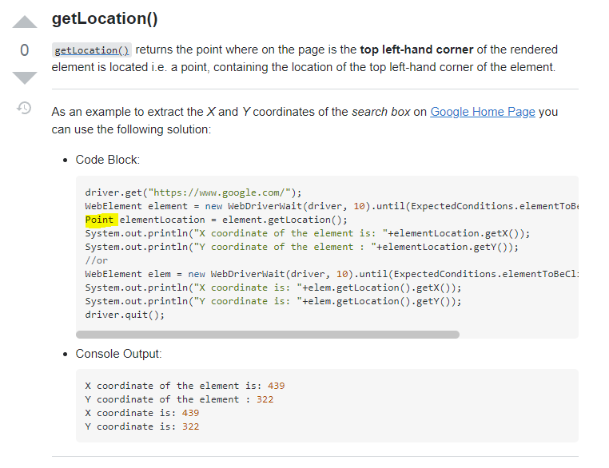
* Dimention and ToolKit class used to get the image or windows dimentions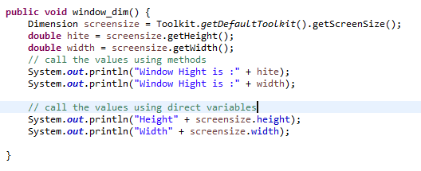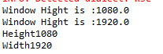
* open incognito window using chrome options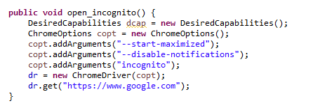
* Keys. chord() method helps to do Key press event done for single and multiple keys through send keys method
* **Multiple key option**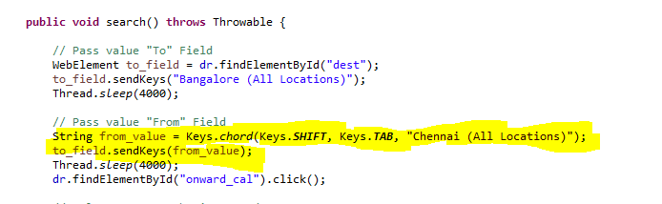
* **Single key option**